DISCLAIMER: This resource guide was created by students, for students. The opinions expressed here do not necessarily reflect those of Purdue University.

Introduction


Accessibility Guidelines for Campus Organizations
A sense of community has been shown to improve both degree completion and mental health of college students. A major way that students find this community is through participation in student organizations. Disabled students have less access to clubs due to a lack of accommodations, contributing to feelings of exclusion and isolation. While not all Disabled students seek formal accommodations due to many systemic barriers, during the 2023-24 school year, 8.6% of students at Purdue University utilized Disability services from the Disability Resource Center, a number that continues to grow. By proactively incorporating accommodations, your student organization can help create a welcoming and accessible environment. The purpose of this guide is to provide clear, easy-to-understand recommendations for making student organizations more accessible. It outlines accommodations and offers practical strategies for integrating accessibility into organizational meetings and campus events.
This website is created by students, for students, and reflects our experiences and research through participation in the Lead Forward grant. This resource is designed to help you create a culture of accessibility at Purdue University. However, true accessibility begins by integrating welcoming practices within your team and organization. Accessibility starts with YOU.

Evolution of This Project
HonorServes, a community service committee within the John Martinson Honors College (JMHC), recognized a significant gap in accessibility within student organizations. In response, executive members Francis Corvin and Natalie Horgan applied to the Lead Forward Fellowship for the 2024-2025 school year with the goal of making HonorServes more accessible. The Lead Forward Fellowship, a competitive program led by Dr. Adam Watkins and Dr. Shaunta Scroggins, provides participants with a monetary grant and a year-long leadership development course (HONR 29500: Lead Forward Fellowship I and II). This program equips JMHC students with mentorship, resources, and guidance to complete a social impact project. Upon acceptance into the fellowship, the HonorServes Accessibility team, supported by advisors Dr. Rosanne Altstatt and Jessi-Alex Brandon, expanded their proposal to include the creation of this guide. Through participation in the Lead Forward Fellowship, HonorServes advances their mandate of intentional, impactful service to the Greater Lafayette community.

A Note on Language Use
This site is written in the language of Disability Pride. While some individuals and communities within the Disability Community prefer Person-First Language (e.g., person with a disability), the majority currently favor Identity-First Language (e.g., Disabled person). To learn more about the preference for Identity-First language, please refer to the articles Demystifying Disability Language by Portland.gov, Disability-Affirming Language: Person-First versus Identity-First Language by Editors Tornoto, Identity-First Language by the Autistic Self Advocacy Network, and On “Person-First Language”: It’s Time to Actually Put the Person First by Alex Kapitan.
Disability, long perceived as a negative trait, is not inherently bad. The rallying cry, “Disability is not a bad word”, has become increasingly common, and we strive to listen to and respect the language that Disabled people prefer. It is vital, however, to always honor an individual’s preferences regarding language. Some communities, such as the Down Syndrome community, strongly advocate for Person-First Language, and that should be the default for their community.

DISCLAIMER: This resource guide was created by students, for students. The opinions expressed here do not necessarily reflect those of Purdue University.

Room Considerations

Building & Room Location
When possible, select a room that is on the ground/first floor to avoid reliance on elevators, which may be inaccessible, malfunctioning, or not present in the building at all. In an emergency situation, elevators may be unusable, making ground-floor locations preferable.
When presenting captions or giving a presentation, make sure to reserve a room with a user-friendly and functional A/V system, including screens capable of displaying captions and meeting materials.
Buildings near parking lots are generally more accessible.
Ensure that the building provides wheelchair-accessible restrooms near the event or meeting location, with enough space for maneuvering a wheelchair and equipped with grab bars for added support. Avoid restrooms with heavy doors or opt for those with an automatic door opener. Gender-neutral bathrooms are often accessible as they provide additional space and can accommodate individuals who may need assistance from another person.

Clear Obstructions
Some rooms have trash cans or recycling bins placed near the door. Moving these and other obstructions from the doorway ensures easier entry for everyone. Additionally, it is important to maintain a clear and accessible pathway within the room.

Dimmer Switch
Rooms with dimmer switches are more accessible, as they allow lighting adjustments to suit different needs. Some members may require bright lighting, while others may be sensitive to light. In such cases, consider keeping one area of the room darker or communicating with attendees to find a lighting option that works for everyone.

Elevator Considerations
Newer buildings tend to have more reliable and accessible elevators.
Large elevators make it easy for mobility devices to enter and turn around. Backing out of an elevator can be difficult.
Some buildings require Disabled individuals to use freight elevators. While this is an option, these elevators can be difficult to locate and may make Disabled individuals feel isolated. Whenever possible, select buildings where the main elevators are large enough for mobility devices.

Propping Doors Open
Propping the door open before the meeting begins makes it easier for members to locate the correct room and improves accessibility for those with limited mobility, especially if the door lacks an automatic opener.

Room Layout
Lecture halls with slopped, fixed seating are among the least accessible room layouts (see example images below).
Rooms with moveable tables and chairs are preferred but ensure proper table placement for accessibility (see “Table Placement” below).
Ensure the room includes multiple spaces that can accommodate wheelchairs or mobility devices, such as near the front, back, and sides, so individuals have a range of seating options and are not limited to one area.
In our experience, accessible entrances that require wheelchair lifts have not been reliable. Our advice is to avoid these entrances and find buildings with ramps if able.
Example: Your club might need a stage. One room uses a wheelchair lift to access the stage; another room has a wheelchair ramp. The room with the wheelchair ramp will be more accessible.

Table Placement
In rooms where tables and chairs can be rearranged, ensure there is enough space for mobility devices to maneuver. Leave unobstructed pathways that are wide enough for accessibility.
If a wheelchair-accessible desk is in the room, do not use it for activities. Keep it available and free of additional chairs.

Examples of Lecture Hall Room Layouts That Should Be Avoided
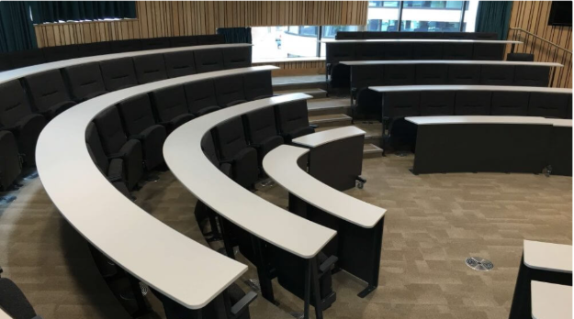
Tiered lecture hall seating with tiered, curved, semi-circular rows.

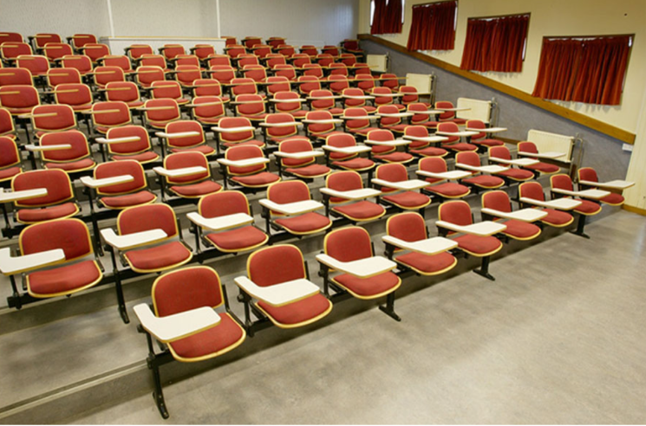
Fixed, tiered lecture hall seating with attached tablet arms.
DISCLAIMER: This resource guide was created by students, for students. The opinions expressed here do not necessarily reflect those of Purdue University.

Marketing and Presentation Considerations

Making Promotional Materials Accessible
When promoting your event, it is important that all materials are accessible to every student, so that more people can engage fully with your event. As a general practice, clearly list all available accommodations (e.g., ASL interpretation, wheelchair access, live captioning) on every piece of promotional material. Doing so helps students determine whether the event will meet their access needs. Additionally, always provide contact information so students can inquire about accessibility or request additional accommodations. The Usable Materials Center at Purdue offers free services to convert materials into accessible formats.

Alternative Text
Alternative text, commonly referred to as alt text, is a brief description of an image on a page. It is particularly beneficial for individuals with low vision or those using screen readers, as it allows them to understand the content and purpose of the image being displayed.
For decorative images, alt text should not be included, as it can distract or confuse users. However, for images that provide meaningful information, such as images containing useful text, icons indicating functionality, comparative visuals, charts, or graphics illustrating processes, alt text should be included.
When writing alt text, ensure it is a concise description that captures the image’s purpose and aligns with the context of the discussion. Avoid including photo credits, copyright information, phrases like “image of” or “photo of”, details already available elsewhere in the content, or information that all readers need to access.

Example of Alternative Text:
❌ Dog
✅Golden retriever wearing sunglasses at the beach.

Braille
If you are distributing printed promotional materials, consider offering accessible formats, such as Braille printing. This format is particularly helpful for students who are Blind or have low vision. Unlike visual fonts, Braille is standardized— it cannot be resized, and its spacing cannot be adjusted. As a result, Braille documents may require more pages than their printed counterparts. Additionally, Braille must be printed on heavyweight card stock paper to ensure the text can be properly embossed and read by touch.
- Factors that reduce Braille printing costs*:
  - Simple paragraph layouts
  - Large or standard font sizes
  - Minimal number of pages
  - Accessible digital text (e.g. Word, TXT, RTF formats)
  - Decorative images only
  - Plan ahead to avoid rush fees
- Factors that increase Braille printing costs*:
  - Scanned documents (non-editable)
  - Hundreds or thousands of pages
  - Tiny or overly decorative fonts
  - Complex visuals (tables, graphs, charts)
  - Images that contain important information
  - Expedited timelines or last-minute submissions
* Information derived from How much does braille cost? by Braille Works
Sample Email Request:
“Hello, my name is [your name] and I am a part of [your organization] at Purdue University. We would like to get a quote for adding Braille to the attached document. We will need [number] copies of it by [date]. We would like to have you print it and send it to us using the recommended paperweight for Braille. It needs/ does not need to be in color. Please let us know the approximate cost and expected delivery date for the attached material (example shown below).”

See the “Fee-Based Services” tab for pricing estimates and recommended companies that offer Braille printing services. The fees provided are based on the poster template shown below, which shows an example of adding accommodations to your promotional materials. Note that these fees may vary depending on the complexity of the poster and the ease of adding Braille to the material.
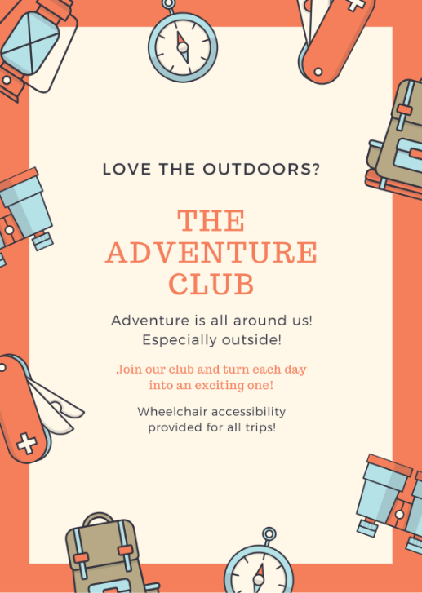
Event poster with information on the provided accommodations

Captioning
Live captioning (also called CART) is important because it provides real-time text of what is being said, making it easier for individuals to follow along and understand the speaker or presentation. It is worth noting that captioning benefits everyone and is not exclusive to a specific group. Whether someone misses a word, momentarily zones out, or struggles to hear clearly, captions help all participants stay engaged and informed.
Live captioning by humans is regarded as more universally accessible than captions created by AI. When possible, captioning services provided by humans should be used. This is especially important when the information being provided is formally presented or involves training.
Regardless of captions being provided by human or AI, mistakes can be made when the audio is poor, the speaker’s voice is not clear, or specialized terminology is used. To reduce errors, please make sure the microphone is in a good position on the speaker, the audio is clear, and terminology sheets are provided to the captioner ahead of the event.
See the “Fee-Based Services” tab for pricing estimates and recommended companies that offer live captioning services.
Although live captions by humans are more accurate and accessible, we understand that their expense may not be in everyone’s budget. Quality microphones and low background noise will improve the accuracy of captioning.
When expense is a barrier, consider the following free automated captioning services, especially in the case of online meetings.
Vendor | Directions
Microsoft PowerPoint | - Go to ‘Slideshow’  - Check the box for ‘Always Use Subtitles’  - Click ‘Subtitle Settings’ to:  - Select your spoken language and subtitle language  - Choose the subtitle position (top of slide, bottom of slide, above slide, or below slide)
Microsoft Teams | - Click ‘More’ (three dots)  - Select ‘Language and Speech’  - Click ‘Show Live Captions’
Zip Captions | - Press the microphone button  - Start speaking to activate captions
Zoom | - Click ‘More’ (three dots)  - Select ‘Captions’  - Click ‘Show Captions’

Colors
Color-blind friendly color palettes, such as those by Bang Wong, IBM Design Library, and Paul Tol (see below), should be considered when designing promotional materials and meeting presentations.
Red-green colorblindness is the most common form of colorblindness, but it is not the only one. Using the tool on the Coloring for Colorblindness website, you can check how your colors appear for each type of colorblindness.
To ensure accessibility, avoid relying solely on color to convey information. Instead, incorporate alternative indicators such as text, symbols, or patterns. When using color for emphasis, consider additional formatting options like italics or boldface.

Bang Wong Color Scheme
Color Name | Hex Code | Red-Green-Blue | Hue-Saturation-Brightness
Black | #000000 | (0,0,0) | (0°, 0%, 0%)
Orange Peel | #E69F00 | (230,159,0) | (41°, 100%, 90%)
Picton Blue | #56B4E9 | (86,180,233) | (201°, 63%, 91%)
Green Haze | #009E73 | (0,158,115) | (163°, 100%, 61%)
Starship | #F0E442 | (240,228,66) | (55°, 72%, 94%)
Deep Cerulean | #0072B2 | (0,114,178) | (201°, 100%, 69%)
Tenné (Tawny) | #D55E00 | (213,94,0) | (26°, 100%, 83%)
Hopbush | #CC79A7 | (204,121,167) | (327°, 40%, 80%)

IBM Design Library Color Scheme
Color Name | Hex Code | Red-Green-Blue | Hue-Saturation-Brightness
Yellow Sea | #FFB000 | (255,176,0) | (41°, 100%, 100%)
Blaze Orange | #FE6100 | (254,97,0) | (22°, 100%, 99%)
Cerise | #DC267F | (220,38,127) | (331°, 82%, 86%)
Cornflower Blue | #785EF0 | (120,94,240) | (250°, 60%, 94%)
Malibu | #648FFF | (100,143,255) | (223°, 60%, 100%)

Paul Tol Color Scheme
Color Name | Hex Code | Red-Green-Blue | Hue-Saturation-Brightness
Contessa | #CC6677 | (204,102,119) | (351°, 50%, 80%)
Jackson’s Purple | #332288 | (51,34,136) | (250°, 75%, 53%)
Chenin | #DDCC77 | (221,204,119) | (50°, 46%, 86%)
Jewel | #117733 | (17,119,51) | (140°, 85%, 46%)
Seagull | #88CCEE | (136,204,238) | (199°, 42%, 93%)
Disco | #882255 | (136,34,85) | (331°, 75%, 53%)
Keppel | #44AA99 | (68,170,153) | (170°, 60%, 66%)
Sycamore | #999933 | (153,153,51) | (60°, 66%, 60%)
Mulberry | #AA4499 | (170,68,153) | (310°, 60%, 66%)

To visualize what these color schemes look like on individuals who are colorblind, please use the Coloring for Colorblindness site by David Nichols.

Digital Media
The four principles of web accessibility ensure that digital content is usable by everyone. These principles include:
- Perceivable: Content must be presented in ways that users can perceive, such as videos with captions or audio descriptions.
- Operable: Websites should be usable by everyone, regardless of the method they choose to interact with the site (e.g., keyboard or mouse).
- Understandable: Clear instructions and content should be provided to ensure easy comprehension of the website.
- Robust: Websites must work well with assistive technologies and be compatible with current and future tools.
Important digital media guidelines include providing text alternatives for all non-text content, maintaining sufficient contrast ratios between text and background (at least 4.5:1 for regular text and 3:1 for large-scale text), and ensuring that content is organized clearly using proper HTML tags for headings, lists, and tables to enhance accessibility for screen readers. To check your contrast ratio, you can use tools like WebAIM Contrast Checker or Contrast Ratio. Additionally, it is important to make sure the purpose of each link is clear from its text alone, avoiding vague phrases like "Click here." Captions should be provided for all prerecorded audio content in synchronized media and should be checked for accuracy before distribution. Finally, text must be readable by screen readers, and images should be accompanied by alternative text or headings.
For additional information on web content, please refer to the Web Content Accessibility Guidelines. To check that your web content is accessible, consider using tools such as Accessibility Insights for Web, Lighthouse, or WAVE.

Font
The most accessible fonts include Calibri, Helvetica, Tahoma, Times New Roman, and Verdana. In general, accessible fonts have adequate paragraph and letter spacing, distinct character heights, and clear differentiation between uppercase and lowercase letters.
Dyslexie Font is specifically designed for Dyslexic individuals, but it is not a free resource.
OpenDyslexic is a free, open-source font created to enhance readability for Dyslexic individuals.
Verdana is a great choice for scientific data because it clearly distinguishes between uppercase “I”, lowercase “l”, and the number “1”, reducing the risk of misinterpretation.
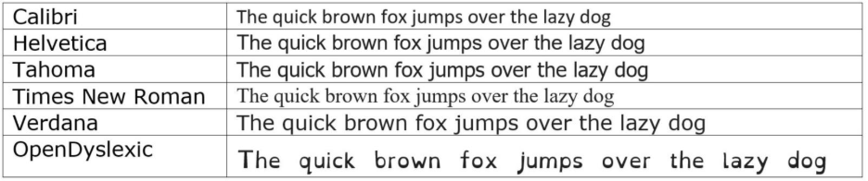Image of all recommended accessible fonts in 12 pt

Sign Language
Unlike captions, sign language is able to convey tone, emotion, and even jokes. There are many types of sign languages that Deaf or Hard of Hearing (HoH) individuals use. While American Sign Language (ASL) is commonly used in the United States, other sign languages exist as well. Therefore, it is important to ask the individual which sign language they use.
A non-comprehensive list of sign languages used in the United States is listed below.

- American Sign Language (ASL)
- Black American Sign Language (BASL)
- Black Sign Variation (BSV)
- Great Basin Sign Language
- Keresan Sign Language
- Navajo Family Sign Language
- Northeast Hand Talk
- Pidgin Signed English (PSE)
- Plains Indian Sign Language (PISL)
- ProTactile (Deaf-Blind sign language)
- Signed Exact English (SEE)
- Southwest Hand Talk
- Tactile Sign Language (Deaf-Blind sign language)

See the “Fee-Based Services” tab for pricing estimates and recommended companies that offer sign language services. To find local interpreters, consult the Registry of Interpreters for the Deaf (RID) or the Indiana Chapter of RID under the “Interpreting Agencies in Indiana” tab. For information about various interpreter certifications, visit the “Interpreter Certificates” tab from the Northwest American Sign Language Associates, Inc. Website.
When using the Registry of Interpreters for the Deaf (RID) search tool, you do not need to click any of the certificates, although they recommend using the Ed:K-12 for educational events. You DO need to select ‘Certified’ in the ‘Category’ field and ‘Yes’ in ‘Freelance Status’ (as shown below).
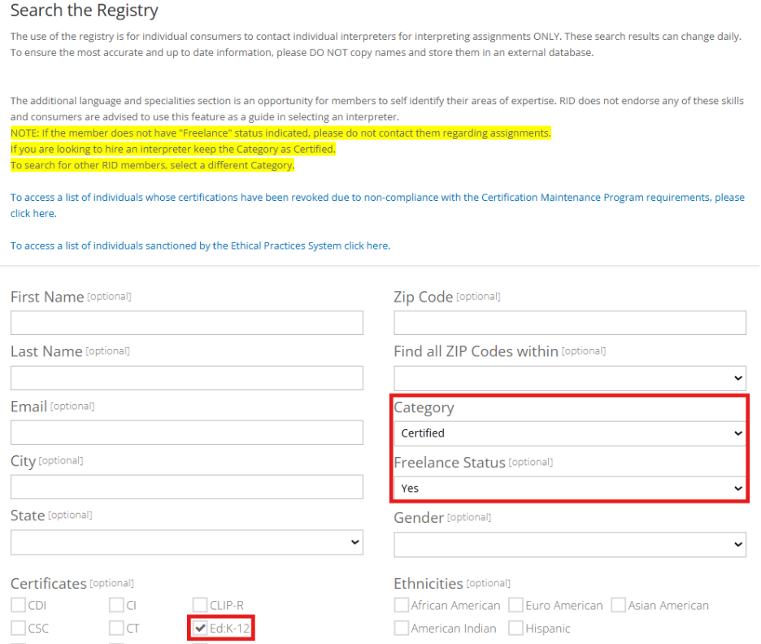Image of the RID search tool with the ‘Category,’ ‘Freelance Status,’ and ‘ED:K-12’ fields highlighted.

Speaking Speed
Speaking at an accessible pace ensures that all audience members can follow along and fully absorb the content. Be sure to include intentional pauses between slides or key points to help your audience process the information and to allow accessibility services, if being used, to keep up.
Practicing beforehand can help you manage your timing, maintain a steady speaking pace, and avoid rushing through your presentation.
If you find yourself short on time, resist the urge to speed up. Instead, focus on identifying and sharing the most important points.
For presentations that involve sign language interpretation or live/closed captioning features (e.g., in PowerPoint, Zoom, or Teams), be extra mindful of your speaking pace. Speak slowly enough to ensure that the interpretation and captions are accurate and easy to follow. This approach helps avoid confusion for those relying on these services and makes it easier for providers to keep up.

Stims/Eye Contact
Many individuals may avoid making eye contact during communication, but this does not necessarily indicate disinterest or distraction. For Autistic or neurodivergent individuals, maintaining eye contact might be a painful sensory experience.
Similarly, for Autistic/ ADHD individuals, stimming is a common behavior used to regulate emotions and manage sensory input. If someone is using their phone or engaging with an object during a conversation or presentation, it is important to understand that they are not being disrespectful or disruptive; it may simply be their way of staying focused or comfortable.
When giving presentations or interacting with others, please keep these characteristics in mind and avoid making assumptions about disinterest or disrespect based on these behaviors.

DISCLAIMER: This resource guide was created by students, for students. The opinions expressed here do not necessarily reflect those of Purdue University.

Outdoor Events
When planning outdoor events, try to choose locations that are accessible by default. For example, areas with sidewalks can reduce or eliminate the need for track mats. Additionally, please consider the following accommodations described below, including access to food and water, availability of shade, use of track mats, and accessible transportation options.

Food/Water
Bring food and water to outdoor events, especially those that are longer in duration. This helps prevent dehydration and fatigue among participants while keeping them comfortable. Please refer to the “Food Considerations” tab for recommendations on providing food at events. Provide ice and salt packets for individuals with postural orthostatic tachycardia syndrome (POTS) or dysautonomia for outside activities. Offer high carbohydrate/sweet snacks, such as lifesavers or applesauce, for people with diabetes or insulin resistance.

Shade
Ensure there are sufficient shade options available during any outdoor event for individuals with dysautonomia or low heat tolerance. If shade is not readily available, set up temporary structures like tents or umbrellas, or offer access to indoor spaces where attendees can take a break from the sun.

Track Mats
For outdoor events with grass or gravel, provide accessible track mats to ensure individuals using wheelchairs can easily navigate the area. These mats should be durable, slip-resistant, and able to withstand various weather conditions. Place track mats along the most common routes to and from entrances, seating areas, and restrooms to ensure smooth and accessible pathways for all attendees.
See the end of the “Accessibility Aids” tab (pages 30-32) for pricing estimates and recommended companies that offer accessible track mats. Some companies, such as Access Trax, offer rental options to help lower the overall cost.

Transportation
When planning off-campus events, it is important to make sure that wheelchair-accessible transportation is available for those who need it. For a more cost-effective option, you can consider using public transportation like CityBus, which serves the Lafayette area. To ensure everything runs smoothly, call them ahead of time to confirm that the wheelchair lift is functioning properly. If possible, test the lift before your event to avoid any unexpected surprises.
For events that are further away or not on the CityBus route, Lafayette Limo is another option that offers accessible transportation that is private to your group. If you have a larger budget, this could be a more convenient and reliable option for transportation.
Phone or Email Communication with a Transportation Vendor:

EXAMPLE 1:
“Hi, my name is [insert name], and I am planning an event that requires wheelchair-accessible transportation. I wanted to confirm that your vehicle is equipped with a working wheelchair ramp or lift. Before the driver departs from your office, please have them test the lift to confirm it is operational for our trip. Ideally, the person who performs the test should also be the driver. If the lift is not working properly, please have them utilize a different vehicle with a functional lift. Thank you for helping us make our trip accessible. I appreciate your assistance.”

EXAMPLE 2:
“Hi, my name is [insert name], and I am reaching out on behalf of [organization name]. We are looking for a vendor who can provide wheelchair-accessible transportation for an upcoming trip.
We have [number of wheelchair users] wheelchair users participating, with a total group size of [number of participants] participants. The trip is scheduled for [insert date], with a pickup time of [insert pickup time] and a return time of [insert return time].
On the day of the trip, please have your office call me at [insert phone number] to confirm that the driver is on their way. We ask that the driver test the lift system prior to departure to ensure it is fully operational, so all riders can have an enriching experience.
Additionally, please ensure that your driver is trained on how to properly secure mobility devices using a tie-down system.
We appreciate your support in helping us make the trip possible. If you have any questions, feel free to contact me by phone at [insert phone number] or by email at [insert email]. Thank you again.”

EXAMPLE 3— 24 HOURS BEFORE THE TRIP (PHONE CALL):
“Hi, my name is [insert name], and I’m calling on behalf of [insert student organization name], a student organization at Purdue University.
We have a trip scheduled with you tomorrow, with a pickup time of [insert pickup time] and a return time of [insert return time].
I’m calling to confirm that the vehicles provided are wheelchair-accessible and that the driver will test the lift system before leaving your office. Please also confirm that the driver is familiar with how to properly secure mobility equipment and will call me to let me know they are on their way.
Thank you for helping us make this trip possible. I hope you have a great day.”
If, during the call, the person you’re speaking with assures you that all their drivers are trained and their lifts are functional, politely request that the assigned driver receive a brief refresher on operating the lift and that a vehicle with a verified working lift be used. Additionally, make sure to confirm the most recent date the vehicle’s lift was tested or serviced, as well as the last time the driver received training.
Of note, back lifts tend to be more reliable than front lifts due to their design and protection from the elements. Therefore, it is good practice to ask about the type of lift available before the event to ensure it will meet accessibility needs.
In addition, ensure there are designated accessible parking spaces near the venue, with clear signage to guide attendees. This will help make sure that everyone has an easy and safe way to access the event.
See the “Fee-Based Services” tab for pricing estimates and recommended companies that offer wheelchair-accessible transportation.

DISCLAIMER: This resource guide was created by students, for students. The opinions expressed here do not necessarily reflect those of Purdue University.

Fee-Based Services
To improve price transparency around accessible accommodations, refer to tables below for estimated costs of wheelchair transportation, captioning, sign language interpretation, and braille transcription. Please note costs were quoted in early 2025 and are subject to change. For most accurate and up-to-date pricing, it is recommended to visit each vendor’s website and request a personalized quote.

Braille Transcription:
Vendor | Approximate Cost | Turnover Time | Contact Information
Adapt to Dot | $1 a braille page (~1 page single spaced)  No shipping and handling fee or minimum quantity  Cannot do flyers— only handouts | 2 weeks | Email: jsparks752@gmail.com  Phone: 1-866-410-8484  5146 Ariana Ct Indianapolis, IN 46227-8217  (Call after emailing to ensure your order has been received)
Braille Enterprises | $50 flat-rate | 2 days | Email: bob@brailleenterprises.com  Phone: 1-410-877-5835
Braille Works | $5 per copy of flyer + transcription fee | 12-15 days | Email: info@brailleworks.com  Phone: 1-813-654-4050
Clovernook | $102.46 for 25 flyers (requirement of 25 flyers) | 5 days (can upgrade to expedite) | Email: sfoulkes@clovernook.org  Phone: 1-513-728-6243
Additional Braille companies to contact include Access USA and National Braille Press.
Pricing in the table above is based on the sample flyer below.
Event flyer used to request Braille quotes

Live (Human) Captioning:
Vendor | Approximate Cost | Contact Information
Aberdeen | $135 per hour | Phone: 1-800-688-6621
CaptioningStar | $110-140 per hour | Email: info@captioningstar.com  Phone: 1-877-323-4707
National Captioning Institute | $120 per hour | Email: hr@ncicap.org  Phone: 1-703-917-7600
Region Captioning, LLC with Shannon Gniadek (Recommended by a Purdue student) | $80 per hour | Email: shannon.gniadek@hotmail.com

Sign Language:
Vendor | Approximate Cost | Sign Language Type (ASL/SEE) | In Person/ Virtual | Contact Information | Address
BeHeard Communications | $120 for 0-2 hours ($60 per additional hour) | ASL, Pidgin Signed English (PSE), SEE, BASL, ProTactile | In Person & Virtual | Email: athomas@beheardcomm.com or rwilliams@beheardcomm.com  Phone: 1-718-607-0815 | 3012 Armory Dr.  Indianapolis, IN 46208
Easterseals Crossroads Deaf Community Services | $150 for 0-2 hours ($18.75 per additional 15-minutes)  *Fees increase if outside typical M-F 6 AM-6PM hours | ASL | In Person & Virtual | Email: interpreting@eastersealscrossroads.org  Phone: 1-317-479-3240 | 4740 Kingsway Dr., 1st Floor  Indianapolis, IN 46205
For more information on different interpretating companies, please refer to the Indianapolis Metropolitan Area Interpreting Agencies website. Please note that some sign language companies may have a two-hour minimum requirement, may require multiple interpreters for events lasting more than two hours, and may charge travel fees or vary their rates based on the date, time, and location of the request.

Wheelchair Transportation:
Vendor | Approximate Cost* | Contact Information
CityBus of Greater Lafayette (Public) | $1 per trip or $2 for a 1-day pass (may be free for Purdue students) | Phone: 1-765-742-7433
Lafayette Limo (Private) | $651 per 4 hours of rental | Email: laflimo@lafayettelimo.com  Phone: 1-765-497-3828
Please note that these prices are dependent on the pick-up/drop-off location and the rental duration.
DISCLAIMER: This resource guide was created by students, for students. The opinions expressed here do not necessarily reflect those of Purdue University.

Food Considerations
When planning an event with food, it’s important to offer accessible options to make sure every guest feels included and no one goes hungry due to dietary needs or preferences. Additionally, provide disposable cups with lids to reduce spills and help individuals with limited mobility, and ensure beverage stations and trash receptacles are easy to find, use, and free of obstructions. In general, avoid making events solely centered around food, as varying dietary needs and preference can affect an individual’s enjoyment of the experience.

Common Food Accommodations
Here are some common food accommodations to keep in mind:
Food Accommodation | Recommendation | Examples
Allergies | Always ask about allergies to offer safe alternatives and prevent cross-contamination | Milk, eggs, fish, shellfish, tree nuts, peanuts, wheat, soybeans, and sesame
Feeding Tube | Provide an option for meals to be blended for individuals with feeding tubes | Ensure all food provided aligns with the diet specified by the healthcare professional
Glucose Intolerance | Offer low-sugar or sugar-free choices | Fruits, vegetables, meat, fish, eggs, beans, and nuts
Lactose Intolerance | Provide lactose-free dairy options (milk, yogurt, cheeses) or plant-based alternatives | Fruits, vegetables, meat, seafood, eggs, nuts, and whole grains
Plain Food Options | Offer simple dishes with minimal ingredients/ plain options for sensory eaters or those with avoidant restrictive food intake disorder (ARFID) | White rice, plain pasta, potatoes, toast, and plain crackers
Vegan/ Vegetarian | Include plant-based or meat-free meal options | Fruits, vegetables, legumes, nuts, seeds, grains, and plant-based proteins

If your event coincides with a religious holiday such as Passover or Eid, consider offering at least one option that caters to those dietary restrictions, such as kosher or halal foods. Local shops such as Baklava Plus near the West Lafayette Public Library have options that meet these needs.
For a smaller budget, consider offering pizza, pasta, or customizable stations (e.g., Chipotle) with various toppings and sauces to accommodate most diets. Double-check nutrition lists and clearly label all food items to minimize cross-contamination. If cross-contamination is unavoidable, provide a warning for attendees.
For a larger budget, consider partnering with a local organic caterer, such as Juniper Spoon, who can accommodate a variety of dietary preferences, including dairy-free, gluten-free, egg-free, vegan, nut-free, and low-acid diets, all while using fresh, high-quality ingredients. Additionally, Sweet Revolution Bake Shop offers fresh-baked pies and pastries made with natural ingredients, providing gluten-free, dairy-free, and vegan options. The Vegan Cheese Lady uses natural, plant-based ingredients to provide gluten-free, lactose-free, and vegan options.

Phone or Email Communication with a Food Vendor:
“Hi, my name is [insert name], and I am planning an event for [insert student organization name] at Purdue University.
We are looking for catering services for an event on [insert date] at [insert time], which will be held at [insert venue location]. We would like to find a caterer who can provide menu options that accommodate various allergies and intolerances, so that all of our guests can fully participate in the event.
We are expecting [insert number of attendees] attendees and would prefer an [insert style of meal, such as sit-down meal, buffet, food truck, or grab-and-go options].
Thank you for your time. We look forward to collaborating with you to make our dining experience a success for our event.”

Considerations for Different Meal Formats
If it is a grab-and-go style meal, ensure that all packaging is easy to open and that food options are easy to eat with utensils.
If it is a buffet, food truck, or grab-and-go option, let the caterer know that you may have individuals who require assistance with getting their food due to physical limitations or mobility issues. If the caterer is unwilling to provide support, ensure that volunteers are available on the day of the event, and clearly communicate that to event participants when explaining the dining procedures.
If it is a meal with table service, let the caterer know that you may have someone who requires assistance with identifying what is being served (if they cannot see it) or cutting their food (if they have mobility or fine motor limitations).

Food Accommodation Request Form
A Food Accommodation Request Form is important to ensure all attendees have access to meals that meet their dietary needs. Please use the Qualtrics Food Accommodation Request Form below as a template to create a customized version for your own organization.
Qualtrics is a survey tool available to all Purdue students. To learn how to use Qualtrics, go to the Qualtrics: Survey Tool by Purdue University.

Food accommodation form template: https://purdue.ca1.qualtrics.com/jfe/form/SV_7WpjfQgEGziDuRw
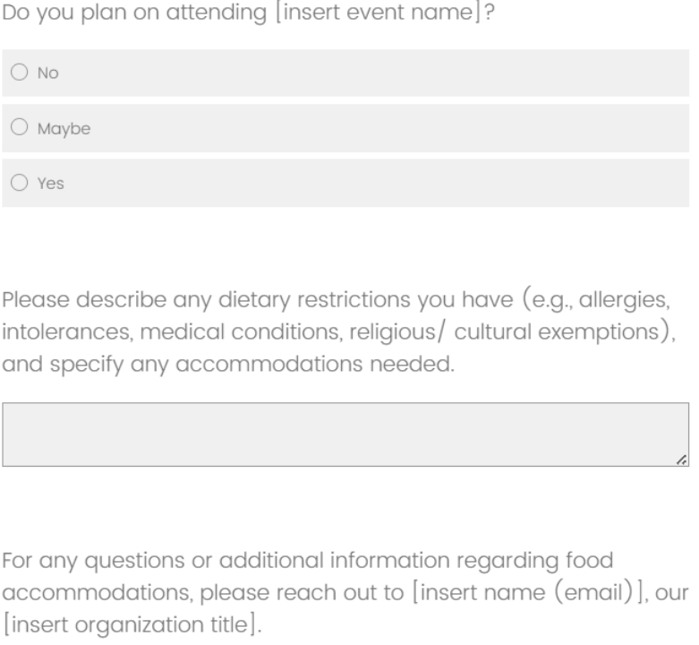
Example of a food accommodation form template, including fields for student attendance, dietary restrictions, and organization contact information.

DISCLAIMER: This resource guide was created by students, for students. The opinions expressed here do not necessarily reflect those of Purdue University.

Accessibility Aids
To make an event accessible, consider including the following supplies:
Accessible Product | Purpose | Product Examples | Product Image
Grabber Stick | Helps participants with mobility or dexterity limitations to reach items without bending or stretching | Grabber Tool— $10 to $20 | 
Left-Handed Scissors | Accommodates left-handed participants in craft-like activities | Left-Handed Scissors— $5 to $10 | 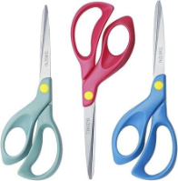
Microphone System | Improves auditory accessibility for all participants, especially those with low hearing, and supports live captioning  Systems for captions will not work for amplifying sound and vice versa. Two systems can be used together as long as you are careful about feedback. | *Comica Vimo Q (four-channel mini wireless microphone)— $130 to $250  Captures sound for captions | 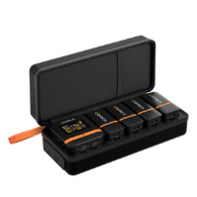
Microphone System |  | HW HAOWORKS Portable Mini Voice Amplifier Wired Headset Microphone Speaker— $20 to $50  Amplifies sound | 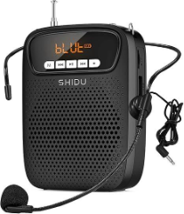
Noise-Reducing Headphones | Reduces overwhelming sounds for participants | ProCase Noise Reduction Ear Muffs— $10 to $20 | 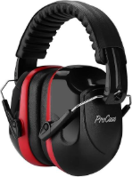
Stim Toys | Provides sensory engagement and regulation for participants with sensory needs  Having a variety of sensory items is recommended | Fidget Slider— $10 to $20 | 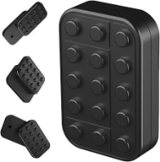
Stim Toys |  | Keyboard Fidget Toy— $5 to $15 | 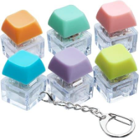
Stim Toys |  | Metal Rotation Fidget Slider— $10 to $20 | 
Stim Toys |  | Sensory Fidget Spinner— $10 to $15 | 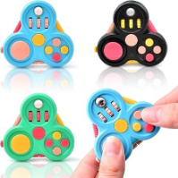
Stim Toys |  | Squeeze Keychains— $5 to $10 | 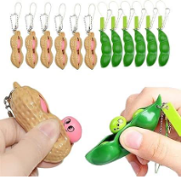
Wheelchair Mats / Tread Mats / Ground Protection Mats/ Grass Protection Mats | Improves accessibility for participants using mobility aids by creating stable, clean pathways across uneven or wet ground  Make outdoor events accessible to everyone  Clarify specific mat traits (NOT FATIGUE MATS) | Access Trax— $385 per 5 mats  36” x 36” x 0.125”  (Minimum purchase of 5 mats) | 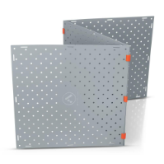
 |  | GRIT Access Trax Mats— $77 per mat  36” x 36” x 0.125”  (Minimum purchase of 5 mats) | 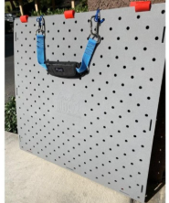
 |  | Mobi-mat Wood-like Roll-up Walkway  3.25’ x 16.5’— $569.00  3.25’ x 33’— $1,099.00  3.25’ x 50’— $1,509.00  3.25’ x 100’— $2,749.00  5’ x 16.5’— $859.00  5’ x 33’— $1,689.00  5’ x 50’— $2,289.00  5’ x 100’— $4,199.00 | 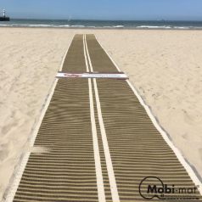
 |  | Northern Tool- Checkers VersaMat Ground Protection Mat, Black, 3ft.W x 8ft.L, Diamond Plate/Pedestrian Plate Tread Design, Model# VM38— $286.52  3’ x 8’  Has pedestrian tread | 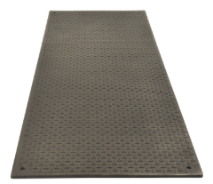
 |  | Start Safety AlturnaMATS®-Ground Protection Mats (Diamond Cleat with Smooth Side)  2’ x 4’— $87.98  2’ x 6’— $131.00  2’ x 8’— $175.03  3’ x 6’— $203.24  3’ x 8’— $228.12  4’ x 8’— $279.74 | 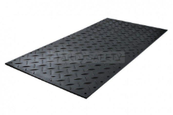

*Product has been personally used by a Purdue student and is highly recommended.
Accessible microphone systems should include features that prioritize clear voice capture over background noise amplification or offer users the ability to easily adjust the output volume to suit their comfort. It is equally important to be understanding and allow individuals to use their own headphones or earbuds if they feel overstimulated by ambient noise. Note that noise-reducing headphones in this context refer to noise-reducing earmuffs, not over-ear headphones.

DISCLAIMER: This resource guide was created by students, for students. The opinions expressed here do not necessarily reflect those of Purdue University.

Indoor and Outdoor Accessibility Checklists
Based on HonorServes' experience with the accessibility project and direct feedback from Disabled students at Purdue University, we have created a general accessibility checklist for indoor events (e.g., meetings) and outdoor events. This checklist is structured around an ideal planning timeline of at least one month in advance. If your timeline is shorter, these are still important considerations to keep in mind. While your team may not be able to complete every item, we encourage you to do as much as possible. Please note that this is not an exhaustive list, and each organization will have different accessibility needs. However, these checklists serve as a helpful starting point for creating proactive accessibility within your organization.

Indoor Event Accessibility Checklist

4 Weeks Before Event
When reserving a room, consider the following:
​​ ☐ The event building is located near a parking lot
​​☐ The event room is located on the ground floor or in a new building with large, reliable elevators
​​​ ☐ The accessible entrance has a wheelchair ramp or doesn't have stairs
​​​ ☐ The room has movable seating/ is not a lecture hall layout
​​​ ☐ There is enough seating for all attendees
​​​☐ The room has adjustable lighting and/or the room allows darker and brighter areas to accommodate for different lighting needs
​​​☐ Restrooms are wheelchair-accessible with doors that are not too heavy or have a door opener. Ideally, there is a gender-neutral single stall restroom
​​​☐ The floor that the room is located on has either a gender-neutral restroom or has both male/female restrooms
​​​☐ If you plan to add Braille to your flyers or any other material, contact the Braille vendor now. You will need to have your materials finished prior to this.
​​​☐ If applicable, hire a sign language interpreter

3 Weeks Before Event
​​​☐ Hire a live captioner / CART services
​​​☐ If you desire to display captions for all attendees and the room does not have a large monitor, arrange for a portable monitor to be available
​​​☐ Consider your event activities and if there are any accessible supplies needed (ex. left-handed scissors). If so, order these now.

2 Weeks Before Event
When designing promotional materials (assuming you want to display them for only one week prior to the event):
​​ ☐ Make sure to use color-blind friendly palette
​​​☐ Use accessible fonts (Calibri, Helvetica, Tahoma, Times New Roman, Verdana, Dyslexie, or OpenDyslexic)
For digital media:
​​​ ☐ Add alt text to images
​​​ ☐ Consult Web Content Accessibility Guidelines
☐ If food is provided, dietary needs and allergies are accommodated. Vegan food is an accessible default option. If desired, a dietary accommodation form can be sent out three weeks prior to the event

Day of Event
​​☐ The room door is propped open for easier access
​​​☐ Trash cans or other barriers are removed from doorways and pathways
​​☐ Tables are arranged to allow space for mobility devices
​​​☐ Accessible desks are clear of additional chairs or items
​​☐ Verify that exterior door openers are working
​​☐ Verify that elevators are functioning

Outdoor Event Accessibility Checklist

4 Weeks Before Event
When scheduling an outdoor event, consider the following:
​​ ☐ The event is located near a parking lot
​​​☐ The location has paved paths going to where the event is being held. If not, provide grass protection mats (track mats) so access is available to everyone
​​​☐ Restrooms are available and are wheelchair-accessible with doors that are not too heavy or have a door opener. Ideally, there is a gender-neutral single stall restroom
​​☐ If the event involves leaving campus, provide wheelchair-accessible transportation
​​​☐ If you plan to add Braille to your flyers or any other material, contact the Braille vendor now. You will need to have your materials finished prior to this.
☐ If applicable, hire a sign language interpreter

3 Weeks Before Event
​​☐ Hire a live captioner / CART services if cell service is available at your location (captions will be viewable on individual cell phones only)
​​☐ If you desire to display captions for all attendees, arrange for a portable monitor to be available that is situated in a shaded area to prevent glare
​​☐ Consider your event activities and if there are any accessible supplies needed (ex. left-handed scissors). If so, order these now.

2 Weeks Before Event
☐ When designing promotional materials (assuming you want to display them for only one week prior to the event)
​​​☐ Make sure to use color-blind friendly palette
​​​☐ Use accessible fonts (Calibri, Helvetica, Tahoma, Times New Roman, Verdana, Dyslexie, or OpenDyslexic)
For digital media:
​​ ☐​ Add alt text to images
​​ ☐​ Consult Web Content Accessibility Guidelines
​​☐ If food is provided, dietary needs and allergies are accommodated. Vegan food is an accessible default option. If desired, a dietary accommodation form can be sent out three weeks prior to the event

Day of Event
​☐​ Shaded areas are available, or umbrellas, tents, or indoor spaces are set up to provide temporary sun relief
​​​☐ Bring water, salt packets, and high-carbohydrate snacks to the event.
☐ Call wheelchair transportation morning of to make sure they send a wheelchair van and that the lift has been checked before it leaves the depot

DISCLAIMER: This resource guide was created by students, for students. The opinions expressed here do not necessarily reflect those of Purdue University.

Funding
We acknowledge that implementing accessibility measures can be expensive. To assist, we have compiled a list of various funding opportunities available at Purdue University to support these initiatives. Unfortunately, accessibility within student organizations is still a new subject, and current funding opportunities are limited. However, as awareness and understanding of accessibility continue to grow, we are hopeful that more funding avenues will become available in the future.

Equipment Support Grant, Student Activities and Organizations:
The Equipment Support Grant provides funding to Purdue student organizations to support their equipment needs. Grants are awarded up to $1000 per academic year, with funding distributed across three periods. Registered student organizations can apply for these grants through their Finance page.

Fundraising:
Organizations can raise funds by selling products, hosting events, or partnering with local restaurants to earn a small percentage of sales. Popular fundraising partners at Purdue University include Chipotle, Panda Express, and Mad Mushroom.

Additional grants that may qualify for funding can be found using the Student Activities and Organizations Funding site.

DISCLAIMER: This resource guide was created by students, for students. The opinions expressed here do not necessarily reflect those of Purdue University.

Additional Resources
An accommodation request form is a simple and effective way to ensure all members of your organization are appropriately supported and able to attend events and meetings that meet their needs. Please use the Qualtrics Accommodation Request Form below as a template to create a customized version for your own organization.
Qualtrics is a survey tool available to all Purdue students. To learn how to use Qualtrics, go to the Qualtrics: Survey Tool by Purdue University.

Accommodation Request Form Template:
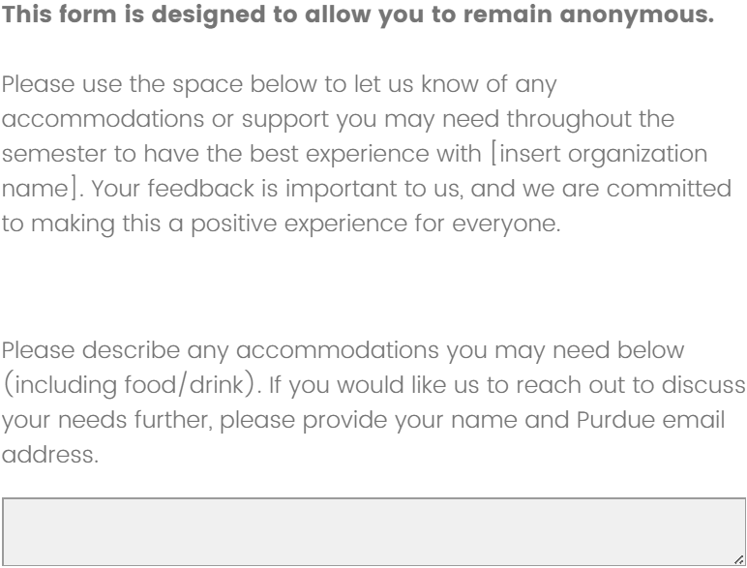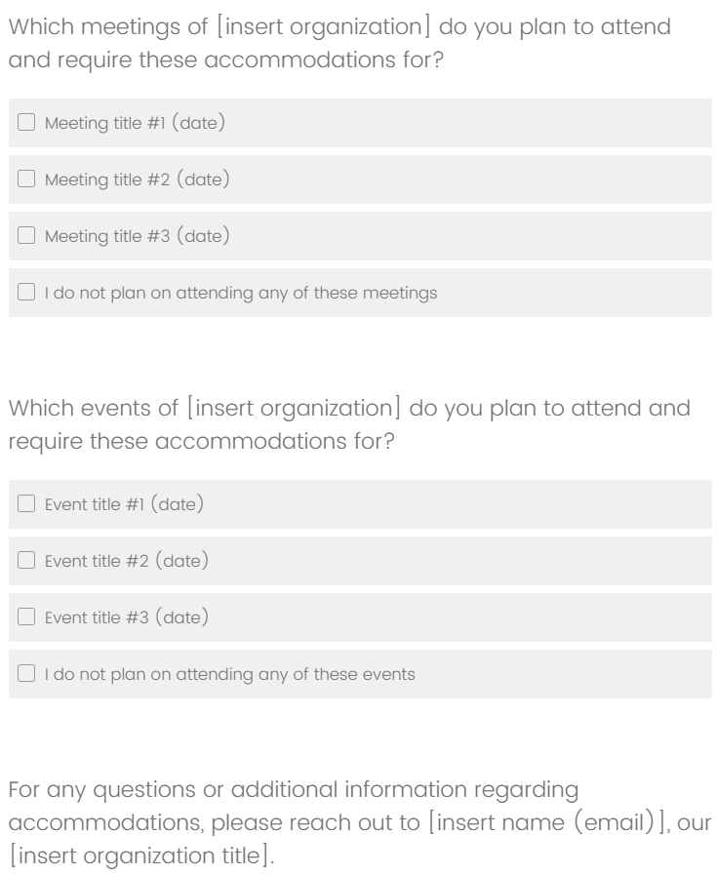
Example of an accommodation request form, including fields for specific accommodation requests, meetings needed, events needed, and contact information.

To learn more about current accessibility standards or discover resources to improve your student organization’s accessibility, please refer to the additional resources below.

Additional Color-Blind Friendly Palettes:
- Colorblind Safe Color Schemes by National Center for Ecological Analysis and Synthesis
- Designing for Color Blindness by Martin Krzywinski
Education on ADA Disability Protections:
- Americans with Disabilities Act
Guidance on Workplace Accommodations:
- Job Accommodation Network
National Center for College Students with Disabilities:
- National Center for College Students with Disabilities
- Disability Rights, Education, Activism, and Mentoring Student Group
Recommendations on Accessible Digital Media:
- Web Content Accessibility Guidelines
Selecting Colors for Research Charts:
- Colour Schemes by Paul Tol
- The Best Charts for Color Blind Viewers by Ivan Kilin
Sign Language Interpreter Certificates:
- Interpreter Certificates by Northwest American Sign Language Associates

DISCLAIMER: This resource guide was created by students, for students. The opinions expressed here do not necessarily reflect those of Purdue University.

Research
To summarize both our work on accessibility and its importance within student organizations, we wrote an article published in the Purdue Journal of Service-Learning and International Engagement. Click the link below to read our article about the harms of inaccessibility and the significance of accessible student organizations.

Abstract:
There are 3.5 million Disabled college students in the United States, with 4,671 utilizing disability services at Purdue University. Nationwide, 8-14% of students in higher education are Disabled, indicating a substantial number of students whose needs should be prioritized and supported. Inaccessibility impacts the way Disabled college students are able to engage with the college experience. Inaccessible classes, restrooms, clubs, job fairs, and campuses create significant barriers which extend far beyond the classroom. Disabled students face challenges in securing scholarships, finding employment, graduating on time, and achieving long-term socioeconomic stability. Recognizing these barriers, HonorServes, a community service student committee at Purdue’s John Martinson Honors College, launched an initiative in August 2024 to improve accessibility within their own events and create an accessibility model for other student organizations. The project aims to assist student organizations at Purdue in being more inclusive of Disabled students while also educating the broader student body on the importance of advocating for accessibility. By creating a culture where accessibility is the norm, HonorServes seeks to ameliorate the long-term negative effects of inaccessibility. Greater accessibility on college campuses—and off them—is vital to ensure that all students have the opportunity to thrive.

(Link Coming Soon) “Inaccessibility Harms: Exploring the Impact of Inaccessible Campus Organizations on Disabled Students”

